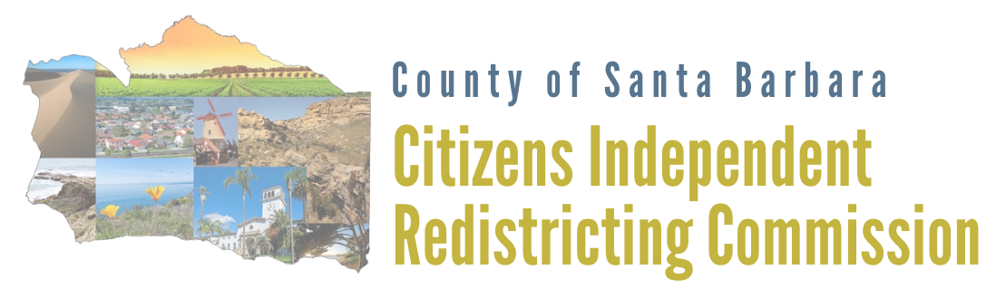

Commissioner Cheryl Trosky, First District

Commissioner Karen Twibell, First District

Commissioner William McClintock, Second District

Commissioner Megan Turley, Second District, Vice Chair

Commissioner Norman “Doug” Bradley, Third District

Commissioner Kevin Kaseff, Third District

Commissioner James Bray, Fourth District

Commissioner Amanda Ochoa, Fourth District

Commissioner Glenn Morris, Fifth District, Chair

Commissioner Michael Hartman, Fifth District

(Vacant), Member-At-Large

COUNTY OF SANTA BARBARA CITIZENS INDEPENDENT REDISTRICTING COMMISSION

PUBLIC MEETING AGENDA

October 14, 2021, 5:30 p.m.
Virtual Zoom Meeting

Zoom: https://zoom.us/j/96627818457 or call (669) 900-6833 or (346) 248-7799 ID: 966 2781 8457

Submit written comment by 5 p.m. one day prior to the meeting to redistricting@countyofsb.org.

Language interpretation and requests for disability-related modification or accommodation, including auxiliary aids or devices, may be arranged by emailing a request to redistricting@countyofsb.org at least 24 hours prior to the Commission meeting.

Para solicitar traducción del idioma o una modificación por discapacidad, incluso los soportes auxiliares y los dispositivos, se puede mandar un correo electrónico a redistricting@countyofsb.org al menos 24 horas antes de la reunión de la Comisión.

Call to Order – Roll Call

Public Comments
Public comment will be allowed on items on this agenda at the time each item is considered. At the end of the agenda under General Public Comments the public may speak on items not on the agenda but within the jurisdiction of the Commission, provided that no action may be taken on off agenda items except as authorized by law. Speakers are limited to no more than three minutes.

Informational Items (Items 1-2)
- Commissioner disclosure of ex parte communications pursuant to County Ordinance Code Sec. 2-10.9A(5)(h) are posted on the commission website at www.DrawSantaBarbaraCounty.org.
- Community-Based Organizations for Outreach Information.
To submit the name of a community-based organization that the Commission should consider contacting with outreach information, visit www.DrawSantaBarbaraCounty.org. Please review the existing the "suggest outreach" list; and, if the organization is not already listed, submit public contact information for the organization using the outreach form. Questions, suggestions, or other information can be emailed to redistricting@countyofsb.org.

Consent Calendar (Item 3)
All matters listed under the Consent Calendar are considered routine and may be enacted by one motion. There will be no separate discussion of these items unless an item is removed by a Commissioner for separate consideration.
- Authorization to use teleconferencing without complying with the teleconferencing requirements imposed by the Ralph M. Brown Act as allowed by AB 361.
Recommended Action: 1) Consider the circumstances of the state of emergency or measures to promote social distancing; and 2) Approve findings that, under existing circumstances, local officials continue to impose or recommend measures to promote social distancing, and it is in the public best interest to continue teleconferencing without compliance with paragraph (3) of subdivision (b) of Government Code 54953.

Discussion Items (Items 4-5)

- Discussion, deliberation, and possible action regarding the commissioner appointment for the At-Large Position and administer oath of office.
- Discussion and possible action regarding future agenda items.
General Public Comments
The General Public Comment period is reserved for comments on items not on this Agenda and for matters within the subject matter jurisdiction of the Citizens Independent Redistricting Commission. The Commission may adopt reasonable regulations, including time limits, on public comments. The Commission may not discuss or take action on any matter raised during the public comment section, except to decide whether to place a matter on the agenda of a future meeting.

Reports from Legal Counsel, Demographer and Communications Consultant

Commissioner Comments

Adjournment

Attachments
Item 3 County Health Department Update
Item 4 Listing of Eligible Applicants

